**NAME-TASMIYA FATHIMA**

**USN-1BM19CS172**

**PROGRAM-5(Flight Database)**

**QUERIES:-**

create database flightdb;

use flightdb;

create table flights(

flno int,

fromplace varchar(15),

toplace varchar(15),

distance int,

departs datetime,

arrives datetime,

price int,

primary key (flno)

);

desc flights;

create table aircraft(

aid int,

aname varchar(15),

cruisingrange int,

primary key (aid)

);

desc aircraft;

create table employees (

eid int,

ename varchar(15),

salary int,

primary key (eid)

);

desc employees;

create table certified (

eid int,

aid int,

foreign key (eid) references employees(eid),

foreign key (aid) references aircraft(aid)

);

desc certified;

insert into flights values(101, 'Bangalore', 'Delhi', 2500, '2005-05-13 07:15:31', '2005-05-13 18:15:31', 5000);

insert into flights values(102, 'Bangalore', 'Lucknow', 3000, '2013-05-05 07:15:31', '2013-05-05 11:15:31', 6000);

insert into flights values(103, 'Lucknow', 'Delhi', 500, '2013-05-05 12:15:31', '2013-05-05 17:15:31', 3000);

insert into flights values(107, 'Bangalore', 'Frankfurt', 8000, '2013-05-05 07:15:31', '2013-05-05 22:15:31', 60000);

insert into flights values(104, 'Bangalore', 'Frankfurt', 8500, '2013-05-05 07:15:31', '2013-05-05 23:15:31', 75000);

insert into flights values(105, 'Kolkata', 'Delhi', 3400, '2013-05-05 07:15:31', '2013-05-05 09:15:31', 7000);

insert into flights values(106, 'Bangalore', 'Kolkata', 1000, '2013-05-05 01:15:30', '2013-05-05 09:20:30', 10000);

insert into flights values(108, 'Lucknow', 'Kolkata', 1000, '2013-05-05 11:30:30', '2013-05-05 15:20:30', 10000);

commit;

select * from flights;

insert into aircraft values(101, '747', 3000);

insert into aircraft values(102, 'Boeing', 900);

insert into aircraft values(103, '647', 800);

insert into aircraft values(104, 'Dreamliner', 10000);

insert into aircraft values(105, 'Boeing', 3500);

insert into aircraft values(106, '707', 1500);

insert into aircraft values(107, 'Dream', 120000);

insert into aircraft values(108, '707', 760);

insert into aircraft values(109, '747', 1000);

commit;

select * from aircraft;

insert into employees values(701, 'A', 50000);

insert into employees values(702, 'B', 100000);

insert into employees values(703, 'C', 150000);

insert into employees values(704, 'D', 90000);

insert into employees values(705, 'E', 40000);

insert into employees values(706, 'F', 60000);

insert into employees values(707, 'G', 90000);

commit;

select * from employees;

insert into certified values(701, 101);

insert into certified values(701, 102);

insert into certified values(701, 106);

insert into certified values(701, 105);

insert into certified values(702, 104);

insert into certified values(703, 104);

insert into certified values(704, 104);

insert into certified values(702, 107);

insert into certified values(703, 107);

insert into certified values(704, 107);

insert into certified values(702, 101);

insert into certified values(702, 108);

insert into certified values(701, 109);

commit;

select * from certified;

-- Query 1

select distinct a.aname from aircraft a where a.aid in (

select c.aid from certified c, employees e where

c.eid = e.eid and not exists(

select * from employees e1 where e1.eid=e.eid and e1.salary<80000

)

);

-- Query 2

select max(a.cruisingrange), c.eid from certified c, aircraft a where c.aid = a.aid group by c.eid having count(c.eid)>3;

-- Query 3

select ename from employees where salary <(

select min(price) from flights where fromplace='Bangalore' and toplace='Frankfurt');

-- Query 4

select avg(e.salary), c.aid from certified c, employees e where c.aid in(

select aid from aircraft where cruisingrange>1000) and e.eid = c.eid group by c.aid;

-- Query 5

select ename from employees where eid in(

select eid from certified where aid in(

select aid from aircraft where aname = 'Boeing'));

-- Query 6

select aname from aircraft where cruisingrange > any (select distance from flights where fromplace='Bangalore' and toplace='Delhi');

-- Query 7

SELECT F.flno, F.departs

FROM flights F

WHERE F.flno IN ( ( SELECT F0.flno

FROM flights F0

WHERE F0.fromplace = 'Bangalore' AND F0.toplace = 'Kolkata'

AND extract(hour from F0.arrives) < 18 )

UNION

( SELECT F0.flno

FROM flights F0, flights F1

WHERE F0.fromplace = 'Bangalore' AND F0.toplace <> 'Kolkata'

AND F0.toplace = F1.fromplace AND F1.toplace = 'Kolkata'

AND F1.departs > F0.arrives

AND extract(hour from F1.arrives) < 18)

UNION

( SELECT F0.flno

FROM flights F0, flights F1, flights F2

WHERE F0.fromplace = 'Bangalore'

AND F0.toplace = F1.fromplace

AND F1.toplace = F2.fromplace

AND F2.toplace = 'Kolkata'

AND F0.toplace <> 'Kolkata'

AND F1.toplace <> 'Kolkata'

AND F1.departs > F0.arrives

AND F2.departs > F1.arrives

AND extract(hour from F2.arrives) < 18));

**SCREENSHOTS OF OUTPUT:-**

**Flights Table:**

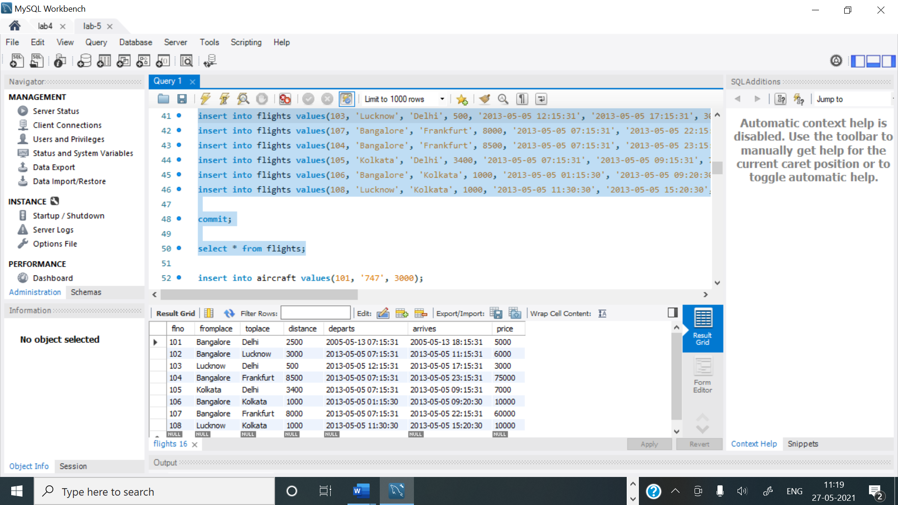

**Aircraft Table:**

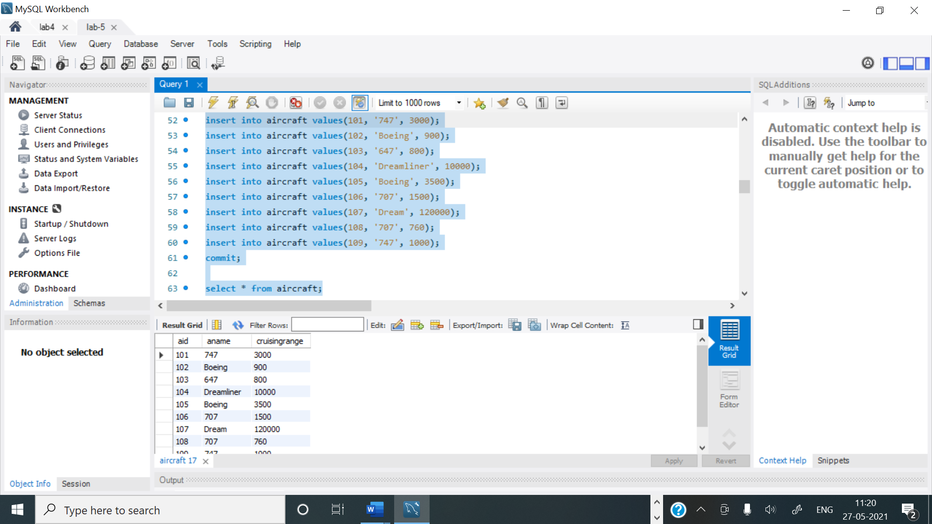

**Employee Table:**

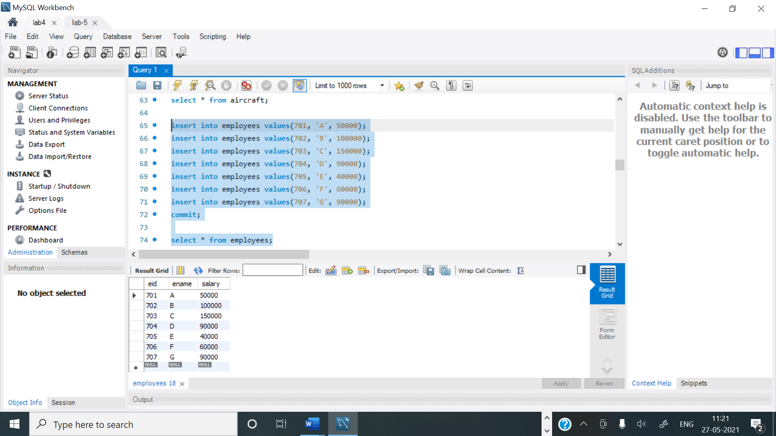

**Certified Table:**

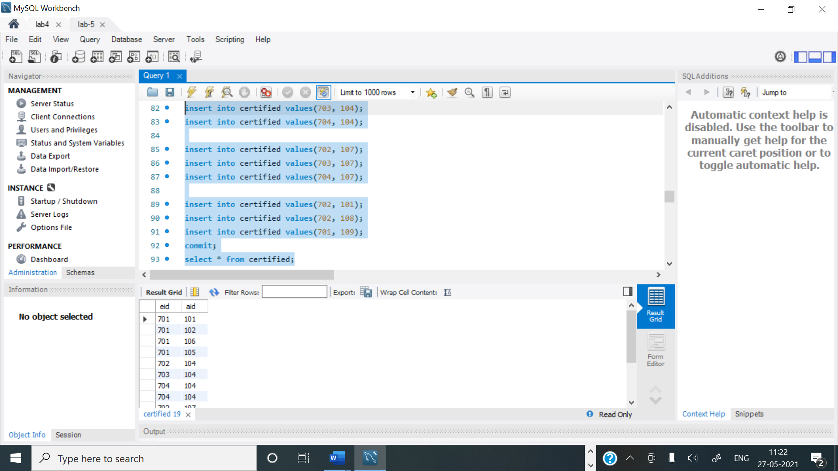

**Query 1:**

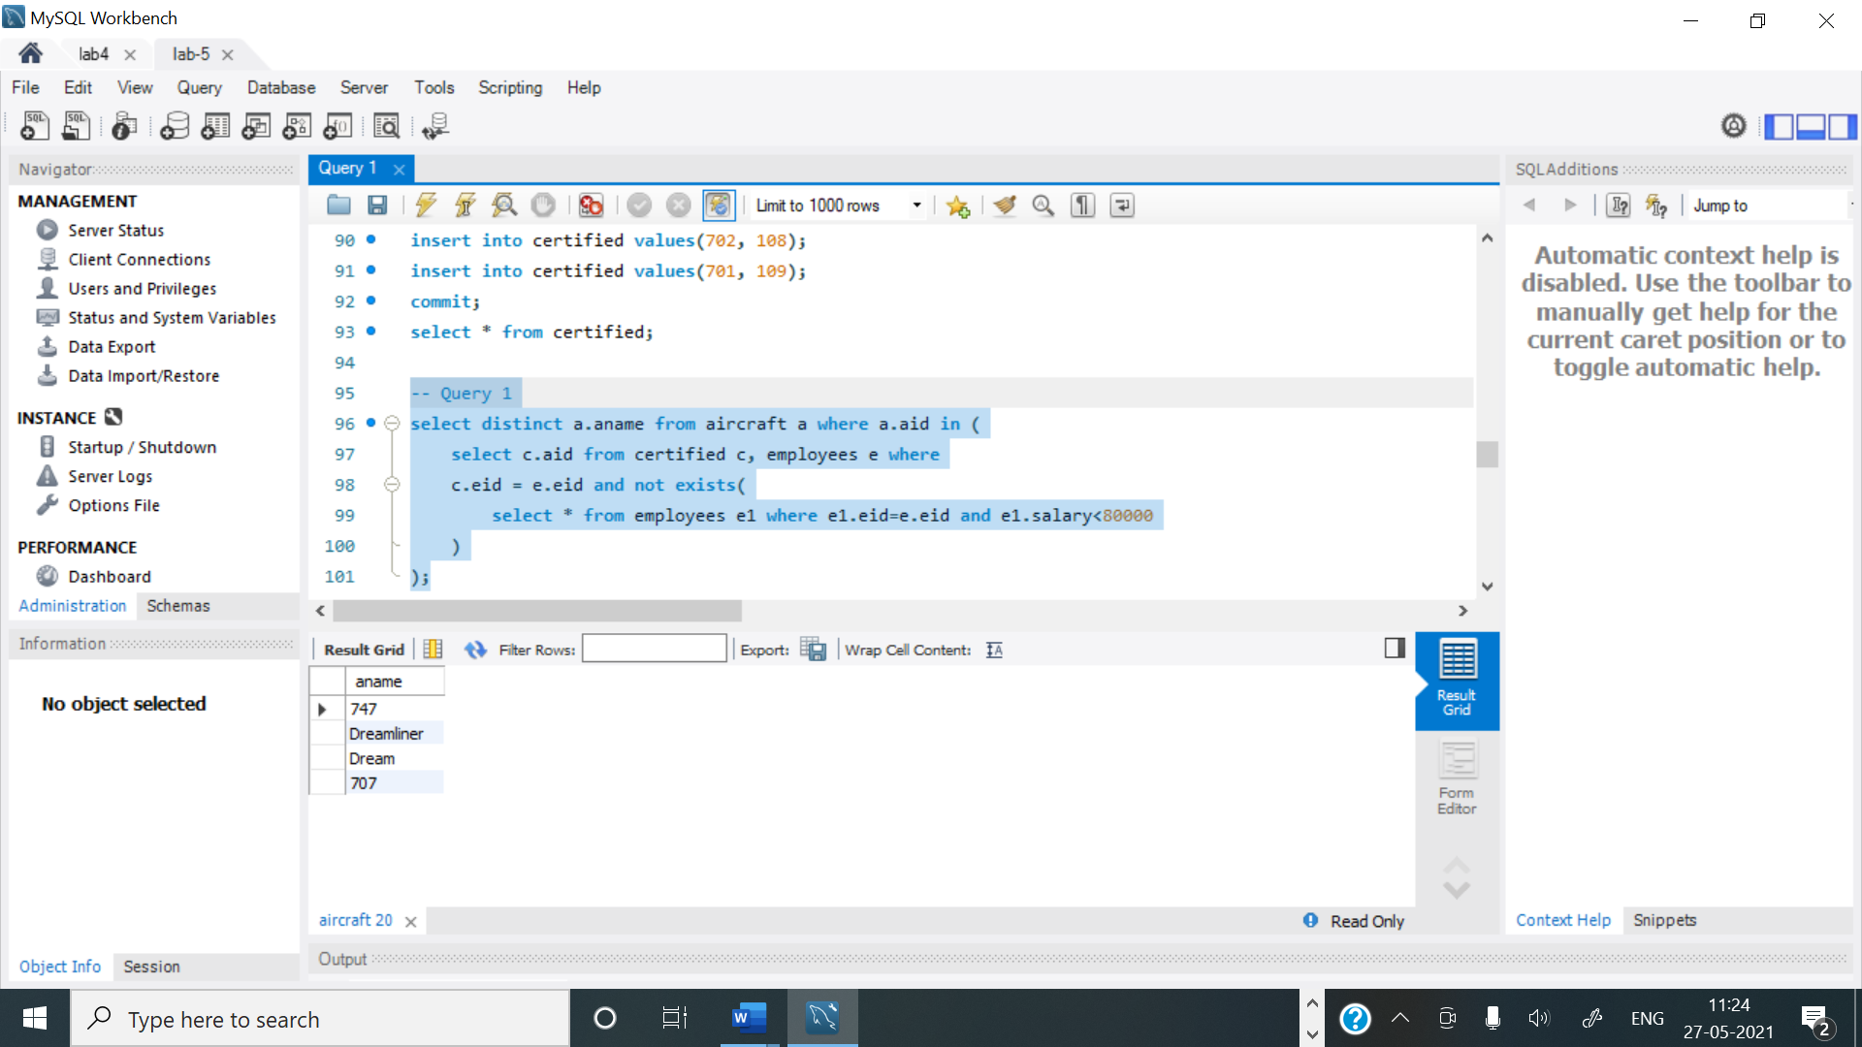

**Query 2:**

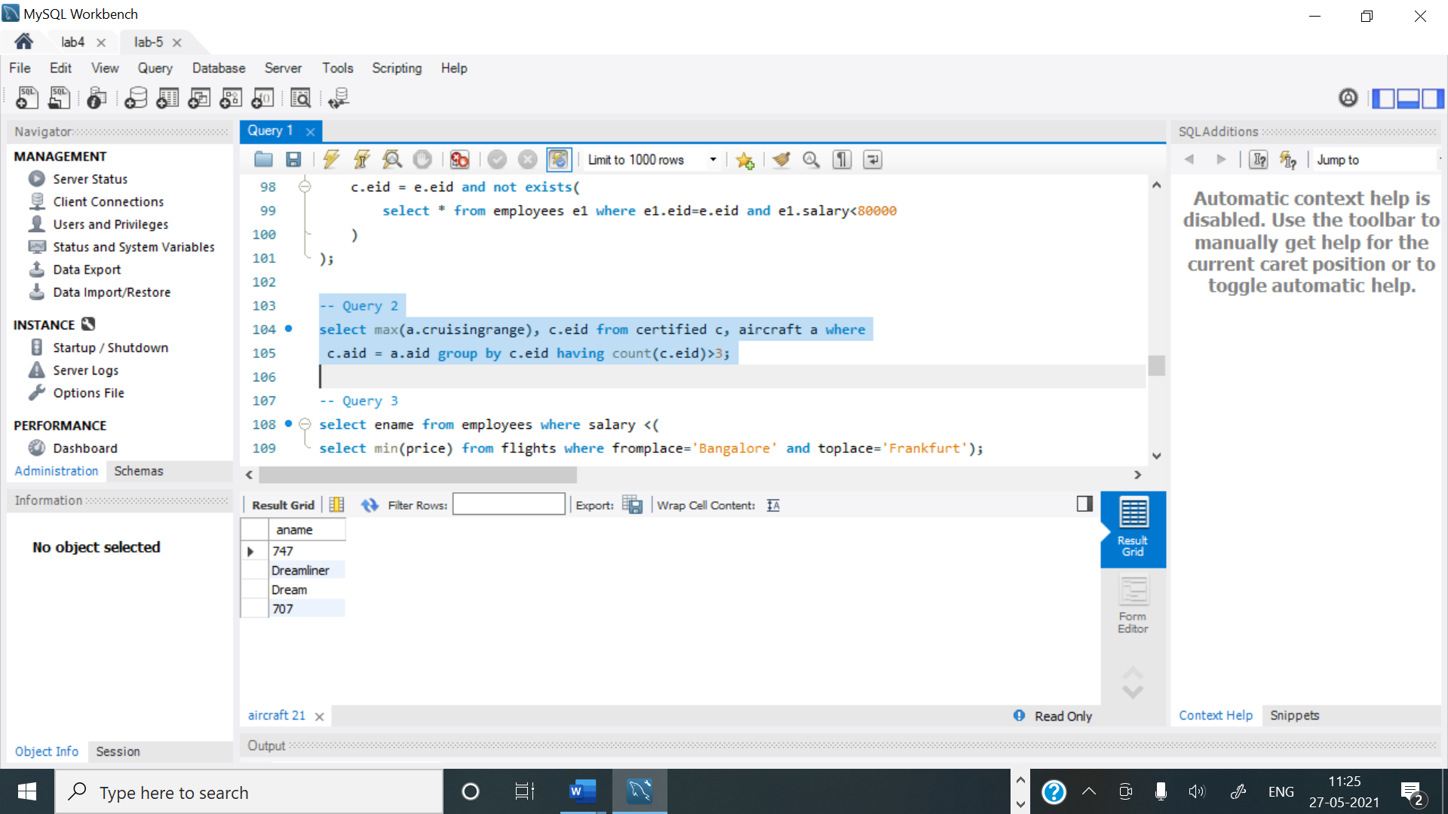

**Query 3:**

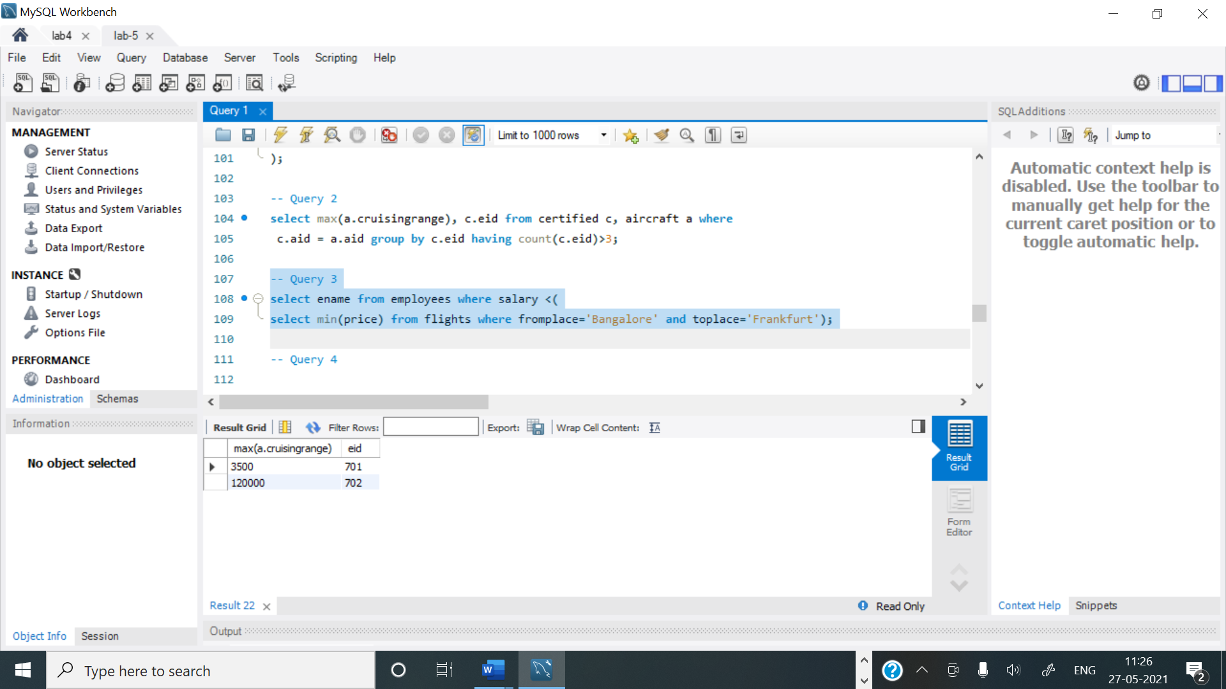

**Query 4:**

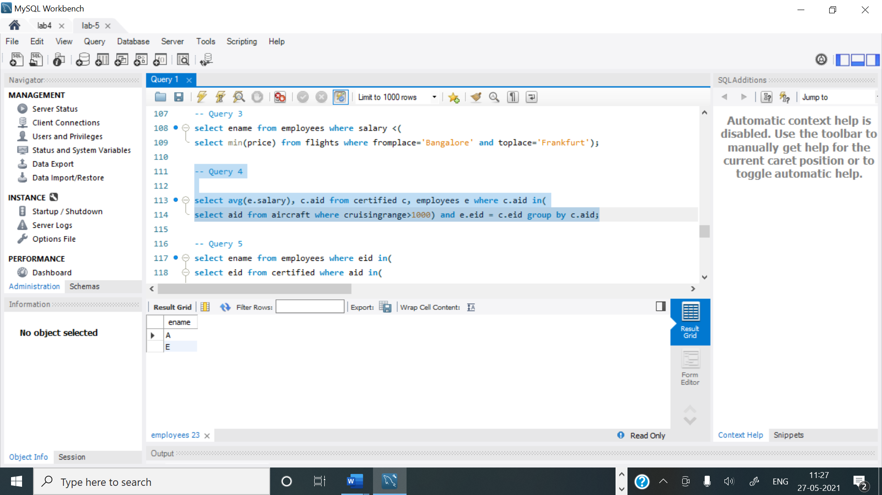

**Query 5:**

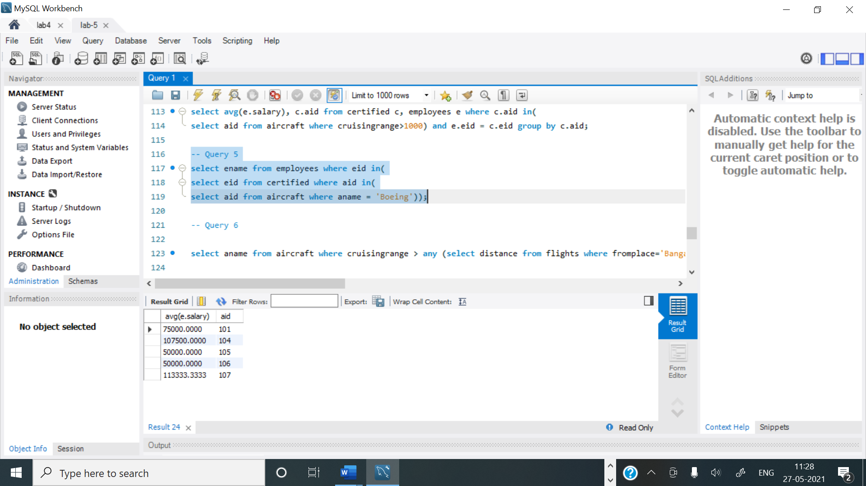

**Query 6:**

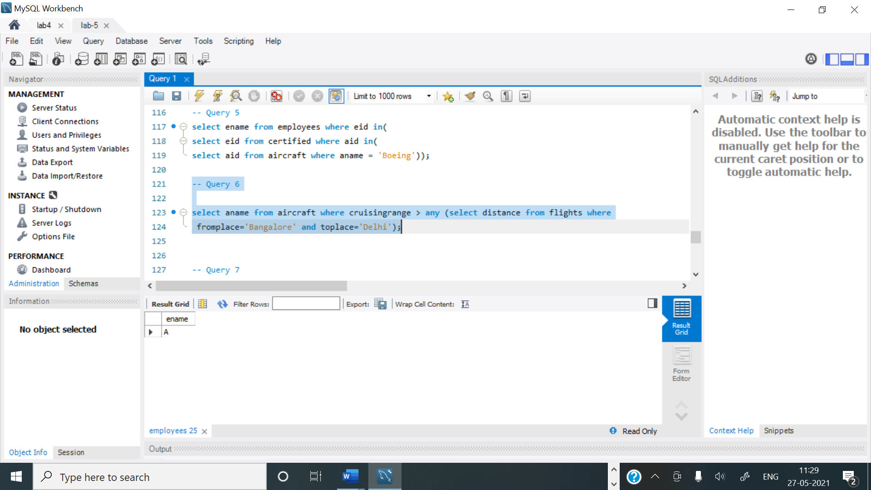

**Query 7:**

